727721EUIT152
SOMA SUNDARI R
DAY_09
TASK 1:
package day9;
import org.testng.annotations.Test;
import org.testng.Assert;
import org.testng.annotations.DataProvider;
public class Calculator {
@Test(dataProvider = "dp")
public void add(Integer n1, Integer n2) {
int actual=n1+n2;
int expected=30;
Assert.assertEquals(actual,expected);
System.out.println("ADDED");
}
@Test(dataProvider="dp")
public void sub(Integer n1,Integer n2) {
int actual1=n2-n1;
int expected1=10;
Assert.assertEquals(actual1,expected1);
System.out.println("SUBTRACTED");
}
@Test(dataProvider="dp")
public void mul(Integer n1,Integer n2) {
int actual2=n1*n2;
int expected2=200;
Assert.assertEquals(actual2,expected2);
System.out.println("MULTIPLIED");
}
@Test(dataProvider="dp")
public void div(Integer n1,Integer n2) {
int actual3=n2/n1;
int expected3=2;
Assert.assertEquals(actual3,expected3);
System.out.println("DIVIDED");
}
@DataProvider
public Object[][] dp() {
return new Object[][] {
new Object[] {10,20 },
};
}
}

OUTPUT:

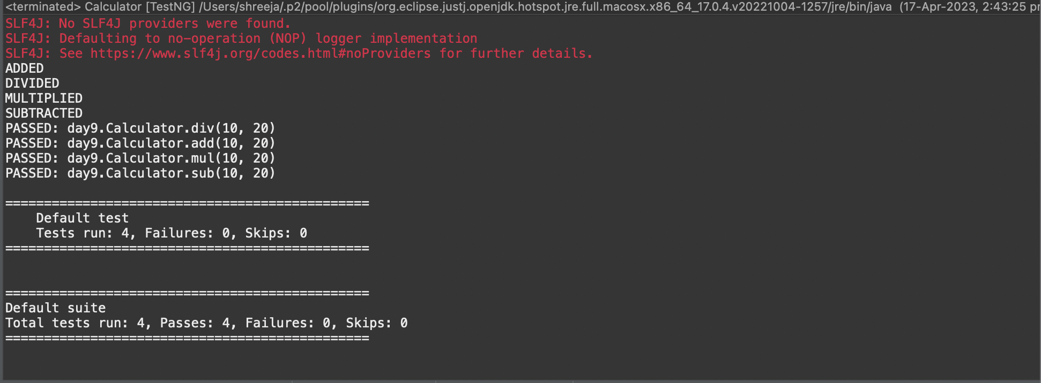

TASK 2:

package com.demo.test;
import java.util.concurrent.TimeUnit;
import org.openqa.selenium.By;
import org.openqa.selenium.WebDriver;
import org.openqa.selenium.chrome.ChromeDriver;
import org.openqa.selenium.chrome.ChromeOptions;
import org.testng.Assert;
import org.testng.annotations.BeforeMethod;
import org.testng.annotations.Test;
import io.github.bonigarcia.wdm.WebDriverManager;
public class task_7 {

WebDriver driver;
@Test
public void tc1() throws InterruptedException {
ChromeOptions co=new ChromeOptions();
co.addArguments("--remote-allow-origins=*");
WebDriverManager.chromedriver().setup();
driver=new ChromeDriver(co);
driver.get("https://www.godaddy.com/");
driver.manage().window().maximize();
Thread.sleep(3000);
String expectedTitle="Domain Names, Websites, Hosting & Online Marketing Tools - GoDaddy IN";
String actualTitle=driver.getTitle();
System.out.println(actualTitle);
Assert.assertEquals(expectedTitle,actualTitle);
String CurrentUrl=driver.getCurrentUrl();
String ExpectedUrl="https://www.godaddy.com/en-in";
Assert.assertEquals(CurrentUrl, ExpectedUrl);
}
@Test
public void tc2() throws InterruptedException{
ChromeOptions co=new ChromeOptions();
co.addArguments("--remote-allow-origins=*");
WebDriverManager.chromedriver().setup();
driver=new ChromeDriver(co);
driver.get("https://www.godaddy.com/");
driver.manage().window().maximize();
driver.manage().timeouts().implicitlyWait(10,TimeUnit.SECONDS);
driver.findElement(By.xpath("//*[@id=\"id-631b049a-e9c0-4d24-8710-c504745206dd\"]/div[2]/div[1]/ul/li[1]/button")).click();
driver.findElement(By.xpath("//*[@id=\"id-631b049a-e9c0-4d24-8710-c504745206dd\"]/div[2]/div[1]/ul/li[1]/div/div[2]/div[1]/ul/li[2]/a")).click();
}
@Test
public void testCase1() {
String expectedTitle="Domain Names, Websites, Hosting & Online Marketing Tools - GoDaddy IN";
String actualTitle=driver.getTitle();
System.out.println(actualTitle);
Assert.assertEquals(expectedTitle,actualTitle);
String CurrentUrl=driver.getCurrentUrl();
String ExpectedUrl="https://www.godaddy.com/en-in";
Assert.assertEquals(CurrentUrl, ExpectedUrl);
}
@Test
public void testCase2() {
driver.manage().timeouts().implicitlyWait(10,TimeUnit.SECONDS);
driver.findElement(By.xpath("/html/body/header/div/section/div/div[1]/nav/div[2]/div[1]/ul/li[1]/button")).click();
driver.findElement(By.xpath("/html/body/header/div/section/div/div[1]/nav/div[2]/div[1]/ul/li[1]/div/div[2]/div[1]/ul/li[2]/a")).click();
}
@BeforeMethod
public void beforeMethod() throws InterruptedException {
WebDriverManager.chromedriver().setup();
ChromeOptions co=new ChromeOptions();
co.addArguments("--remote-allow-origins=*");
driver=new ChromeDriver(co);
driver.get("https://www.godaddy.com/");
driver.manage().window().maximize();
Thread.sleep(3000);
}
}

OUTPUT:
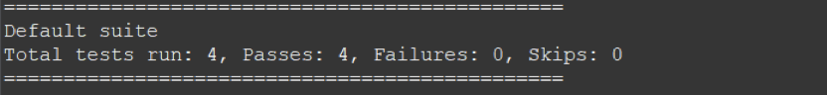

TASK 3:
package com.demo.test;
import org.testng.annotations.Test;
import io.github.bonigarcia.wdm.WebDriverManager;
import org.testng.annotations.BeforeMethod;
import java.util.concurrent.TimeUnit;
import org.openqa.selenium.By;
import org.openqa.selenium.WebDriver;
import org.openqa.selenium.chrome.ChromeDriver;
import org.openqa.selenium.chrome.ChromeOptions;
import org.testng.Assert;
import org.testng.annotations.AfterMethod;
public class D_9_T_2 {

WebDriver driver;
@Test
public void check() throws InterruptedException {
Thread.sleep(5000);
String url = driver.getCurrentUrl();
String title = driver.getTitle();
String expectedUrl = "https://www.godaddy.com/en-in";
String expectedTitle = "Domain Names, Websites, Hosting & Online Marketing Tools - GoDaddy IN";

Assert.assertEquals(url,expectedUrl);
Assert.assertEquals(title,expectedTitle);
}
@BeforeMethod
public void BeforeMethod() {
ChromeOptions co = new ChromeOptions();
co.addArguments("--remote-allow-origins=*");
WebDriverManager.chromedriver().setup();
driver = new ChromeDriver(co);
driver.get("https://godaddy.com/en-in");
driver.manage().window().maximize();
}
@AfterMethod
public void AfterMethod() {
driver.close();
}

@Test
public void f2() throws InterruptedException{
ChromeOptions co=new ChromeOptions();
co.addArguments("--remote-allow-origins=*");
WebDriverManager.chromedriver().setup();
driver=new ChromeDriver(co);
driver.get("https://www.godaddy.com/");
driver.manage().window().maximize();
driver.manage().timeouts().implicitlyWait(10,TimeUnit.SECONDS);
driver.findElement(By.xpath("//*[@id=\"id-631b049a-e9c0-4d24-8710-c504745206dd\"]/div[2]/div[1]/ul/li[1]/button")).click();
driver.findElement(By.xpath("//*[@id=\"id-631b049a-e9c0-4d24-8710-c504745206dd\"]/div[2]/div[1]/ul/li[1]/div/div[2]/div[1]/ul/li[2]/a")).click();
}

@Test
public void f3() throws InterruptedException{
ChromeOptions co=new ChromeOptions();
co.addArguments("--remote-allow-origins=*");
WebDriverManager.chromedriver().setup();
driver=new ChromeDriver(co);
driver.get("https://www.godaddy.com/");
driver.manage().window().maximize();

Thread.sleep(5000);
String url = driver.getCurrentUrl();
String expectedUrl = "https://www.godaddy.com/en-in";
Assert.assertEquals(url,expectedUrl);
}
}
OUTPUT:
